**IEEE IES STUDENTS AND YOUNG PROFESSIONALS  
PAPER ASSISTANCE PROGRAM (IES-SYPA)**

The Young Professionals & Student Activity Committee (YPS-AC) of the Industrial Electronics Society (IES) offers financial support of up to 1500 USD to the IEEE IES S&YP members to attend IES conferences.

IES SYPA will be a new format of mentoring events for the student and young professional (S&YP) members of the IEEE Industrial Electronics Society. This event will give IEEE IES S&YP members a unique opportunity to ask questions and get professional advice directly from IEEE Fellows, the IES President, AdCom members, and experienced colleagues. We encourage all conference participants to join!

This event includes tutorials from academia and industry, a 3M video session, and an open discussion forum.

* **How to Apply**
* You MUST be an IEEE member. Whether Student, Graduate Student or Young Professional (YP). You are considered YP up to 15 years after your graduation.
* You MUST be a member of the IEEE Industrial Electronics Society.
* You MUST have a paper accepted at the conference as an author or co-author and be the person to present it at the conference.
* You MUST reside outside the city in which the conference is held.
* Your paper should be fully registered.
* You SHOULD NOT have received the SYPA in the last 2 years.
* In the submission system, if you toggled the correct membership (Student or YP), the “IEEE-IES SYPA” tab will appear once the paper is accepted. Click on that and submit the required information/document/video.
* You MUST prepare a video and send it according to the following rules:
  + The length MUST be 3 minutes. Even 1 second more or less is not tolerated.
  + Avoid using PowerPoint slides for most of the video. Only up to 30% of the video (1min) can be from the presentation slides. Be creative and generate interactive content! Watch more videos to get ideas.
  + Some seconds MUST be devoted to the paper information such as title, authors, affiliations, your university, company, research team, etc.
  + At least the last 5 seconds MUST contain the **Acknowledgment to IEEE IES for the IES-SYPA**!
  + The video MUST be shared through sharing websites like Dropbox, Google Drive, OneDrive, etc. Make sure to provide the link without requiring permission (MUST be viewable to anyone who has the link)

Once your paper is accepted, the IEEE-IES SYPA tab will appear, and you can apply for it as:

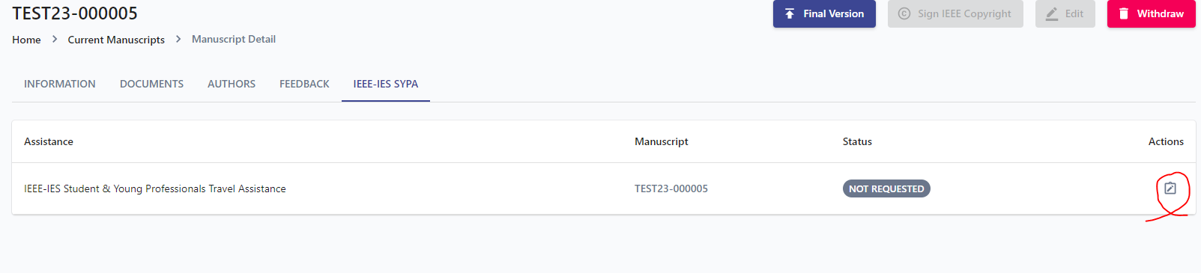

Ensure you have turned on the required membership options in your profile at the top-right corner of the submission system. You should be an IEEE and IES member and also a Student or Young Professional.





For any questions regarding the SYPA application **submission** issues, please contact the conference support team directly at [conferences@ieee-ies.org](mailto:conferences@ieee-ies.org)

* **Review Process**

The committee members will review videos in 2 rounds. All applicants will be given one chance to update their videos according to the 1st-round comments. Then, the final video will be reviewed in 2nd-round and receive an average score based on its **impact, creativity, style, presentation, video quality, etc.** The ones with the highest scores from both paper and video reviewers will be selected as the winners of the IES-SYPA. They will receive financial support for travel expenses and a diploma during the Gala dinner.

The winners’ videos will be uploaded on the [IES YouTube Channel](https://www.youtube.com/@ieee-ies), and you will receive an email including the link to your video on the IES YouTube Channel. You should copy that link to the IES Facebook Event page of the conference and wait for the thumbnail to appear, then post it!

Moreover, you should similarly post the link of your video to the IEEE Collabratec. You are also allowed to share it on any other websites. The direct link to the Facebook event page and IEEE Collabratec Group will be sent in the same email and will be available on the conference website.

* **Timeline**
* IES SYPA Application submission deadline: 05/02/2024, 22:00 GMT-4.
* 1st-round general comments on the videos will be sent by 11/02/2024
* Submission of the final 3-minute video: 18/02/2024, 22:00 GMT-4
* Announcement of winners: 25/02/2024
* **To Receive the Travel Assistance**

1. You MUST be on the list of final SYPA recipients.
2. You MUST attend the conference and give 3 3-minute speech during the **3-Min Video Session.**

DO NOT FORGET to bring your video file to the 3M Video Session. The videos will be displayed on a large screen, and you will talk to the audience for 3 minutes. So, your speech should be very brief and informative.

All information (including the place, date, and time) for the 3M Video Session and the ceremony to receive the Diplomas will be announced by the first day of the conference.

The fund can cover your expenses, including conference registration, transportation, and accommodation. So, keep your receipts and use the **Concur** platform to submit the expenses and other required information. All instructions can be found on the SYPA page of the conference.

It should be noted that if many applicants have obtained a high score, the committee can reduce the travel assistance amount to 1000 USD per applicant. This exceptional measure is to support the travel of a higher number of excellent applicants.

* **Some tips to prepare your video**

1. The 3M video session aims to help researchers/engineers (students and young professionals) learn how to advertise their projects to the public and promote the authors. Whether your work is theoretical or by simulations, you are expected to prepare the movie as interactive, live, and interesting for the viewers. Record some minutes from running results in the software during simulation or practical tests.
2. Record some videos from your hardware design or even software results (e.g., the screen of your computer) while they are running. Or add some discussion with co-authors, research team, etc. At least 70% of your video should include interactive parts rather than solid slides.
3. It is recommended that you present the work with your own voice during the video recording. Please present it in a different way than a PowerPoint presentation. Your video will be placed on the IES YouTube Channel and should attract viewers.
4. Showing some information on the video using simple texts as subtitles is also recommended. Note that the voice is helpful for YouTube viewers; however, during the conference, it will be replaced by your 3M speech. The video may be displayed without sound during the S&YP 3-Min Video Session.
5. Sometimes, background music could make your video much more enjoyable.
6. The audience already saw your paper presentations, so be different in your videos.
7. Try to make people interested in your videos. Devote some seconds of the video to your office, lab, or any place you work in and show the stuff you use for that project, introduce co-authors and supervisors, explain motivation, etc.
8. The 3M video does not need to show the details of your work. Some concepts are enough to attract people’s attention. Deep theoretic and mathematics are useless for advertising your project to people with different interests.
9. Note that the video should be impressive and interactive. Static pictures interest only some. Find gifs or flash images from the Internet.
10. Ensure you have the copyright for materials used in your video, including animations, songs, photos, etc.

You can watch a good example of a 3Min video recorded at MIT here.

<https://www.youtube.com/watch?v=inX07rt1kgU>

Take a look at other videos posted by young researchers (young professionals and students) for the IES-SYPA at the following links:

<https://www.youtube.com/watch?v=WJf6z_1eTqY>

<https://www.youtube.com/watch?v=G9-Tb0H1soU>

<https://www.facebook.com/appa.rao.750/videos/10154015783559666/>

--

Hani Vahedi

On behalf of the S&YP Committee